Project Development Phase Model Performance Test

|  |  |
| --- | --- |
| Date | 24 November 2022 |
| Team ID | PNT2022TMID25156 |
| Project Name | STATISTICAL MACHINE LEARNING APPROACHES TO LIVER DISEASE PREDICTION |
| Maximum Marks | 10 Marks |

Model Performance Test

|  |  |  |  |
| --- | --- | --- | --- |
| **S.No.** | **Parameter** | **Values** | **Screenshot** |
| 1. | Metrics | **Classification Model:** Accuracy Score- & Classification Report | Random Forest Algorithm, Gradient Boost Algorithm, AdaBoost Algorithm |
| 2. | Tune the model | Hyperparameter Tuning method | Confusion Matrix |

The screenshots are provided below for the above-mentioned table.

1. **Metrics**

Model: Random Forest Algorithm

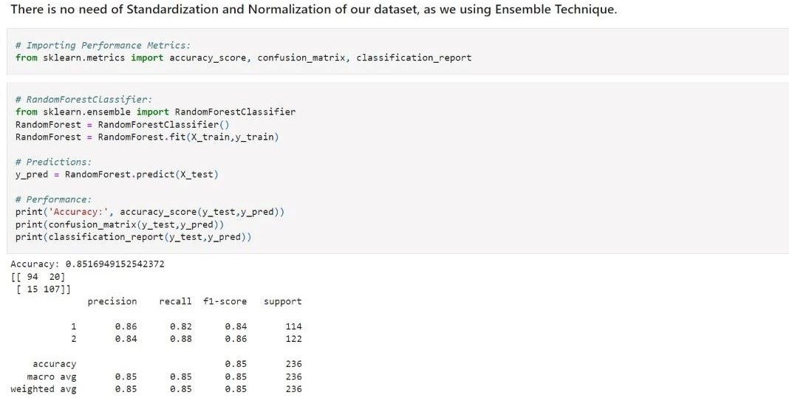

GradientBoost Algorithm

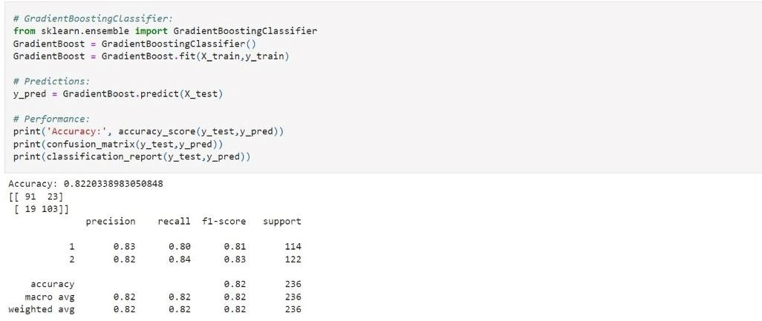

AdaBoost Algorithm

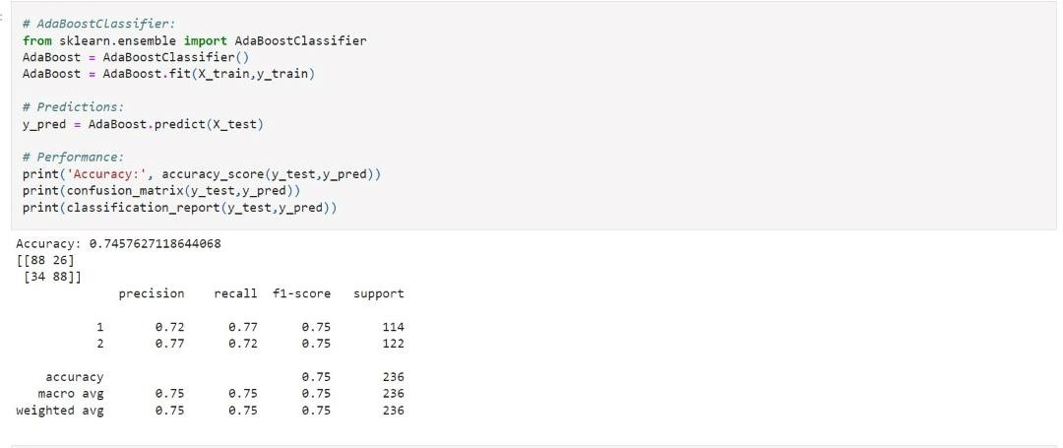

1. **Tune the model Confusion Matrix**

